USNA Class of 1964 KIA in Vietnam and on the WALL
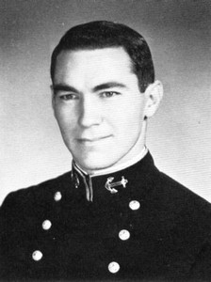
Virgil K. Cameron, LTJG, USN
DOD: 7/29/66
Panel 9E, Line 85
LTJG Virgil K. Cameron was U.S. Navy pilot assigned to Attack Squadron 155 (VA-155) aboard the USS Constellation. On July 29, 1966, LTJG Cameron was the wingman in a flight of 2 A-4E jets on an armed reconnaissance mission over North Vietnam. At 9:25 AM, Cameron commenced a divebomb attack against a barge near Phu Dien Chau in Nghe Tinh Province. He made a low-angle dive with an entry altitude of 5000 feet. The flight leader was above Cameron’s A-4E when it was hit by antiaircraft fire. The enemy fire was visible by flak puffs and the sound of automatic weapons audible as they fired. A stream of fuel came from Cameron’s starboard wing about midway in his dive. The aircraft oscillated slightly and then began to roll left and burst immediately in a fireball. No ejection attempt or parachute was observed, nor was there a radio signal received by the flight leader. The flight leader searched the area thoroughly and saw only a burn spot on the ground where the aircraft impacted. Cameron’s remains were not recovered and he was declared Missing in Action. During the time he was missing he was promoted to Lieutenant Commander. In September 1990, Cameron’s remains were repatriated and positively identified in August 1999. He was interred at Arlington National Cemetery.
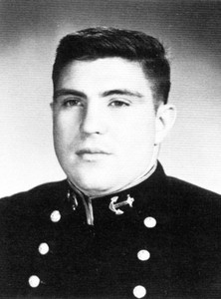
Thomas J. Holden, 1st LT USMC
DOD: 10/22/66
Panel 11E, Line 97
http://www.usna64.org/USNAHolden.asp
- 1st Silver Star Awarded for actions during the Vietnam War
The President of the United States of America takes pride in presenting the Silver Star (Posthumously) to First Lieutenant Thomas James Holden (MCSN: 0-89419), United States Marine Corps, for conspicuous gallantry and intrepidity in action while serving as a Platoon Commander with Company G, Second Battalion, Third Marines, THIRD Marine Division (Rein.), FMF, in the Republic of Vietnam on 23 August 1966. During Operation ALLEGHENY, First Lieutenant Holden's platoon was dispatched to relieve a platoon sized patrol which was pinned down by heavy crossfire from enemy automatic weapons. Enemy strength was estimated at nearly sixty and the ambush had occurred just 200 meters from the Company perimeter. As his platoon neared the ambush site, it was also brought under intense automatic weapons fire, coupled with grenades and M-79 rounds thrown and fired from the underbrush and the trees to the front and both flanks. Realizing the seriousness of their situation, First Lieutenant Holden began moving from man to man and squad to squad, encouraging them forward to regain the momentum of the assault. Fearlessly exposing himself to enemy fire, he led his men in a furious attack, routing the enemy and rescuing the beleaguered patrol. His inspiring leadership, aggressive fighting spirit and courageous initiative upheld the highest traditions of the Marine Corps and of the United States Naval Service.
- 2nf Silver Star Awarded for actions during the Vietnam War
The President of the United States of America takes pride in presenting a Gold Star in lieu of a Second Award of the Silver Star (Posthumously) to First Lieutenant Thomas James Holden (MCSN: 0-89419), United States Marine Corps, for conspicuous gallantry and intrepidity in action while serving as Executive Officer of Company G, Second Battalion, Third Marines, THIRD Marine Division (Rein.), FMF, in the Ap Ba Area in the Republic of Vietnam on 22 October 1966. During an assault through open rice paddies in a torrential rain, the Company's Third Platoon became pinned down by a heavy volume of small-arms and automatic weapons fire. First Lieutenant Holden moved aggressively to aid the Platoon. Upon learning that both the Platoon Commander and the Platoon Sergeant had been wounded, he took command of the platoon and directed the base of fire in an attempt to gain superiority over the enemy while simultaneously directing the extraction of that portion of the platoon which was pinned down. Although constantly exposed to the heavy volume of accurate enemy fire, he resolutely continued in the attack until he fell, mortally wounded. By his outstanding leadership, indomitable fighting spirit and unwavering devotion to duty, First Lieutenant Holden upheld the highest traditions of the Marine Corps and of the United States Naval Service. He gallantly gave his life for his country.

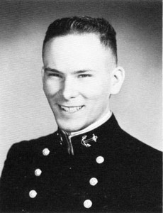
Gerald W. Siebe, LTJG USN
DOD: 10/24/66
Panel 11E, Line 115
On October 26, 1966, there was a flare fire aboard the aircraft carrier USS Oriskany operating in the Gulf of Tonkin off the coast of Vietnam. Two sailors were re-stowing unexpended MK-24 Mod 3 flares when one was accidentally dropped. The igniter had not been reset to SAFE. As it fell, the safety lanyard was inadvertently pulled, actuating the flare. For reasons known only to him, one of the sailors picked up the armed flare, threw it into the magazine locker, and closed the door. Some 2.75-inch rocket warheads loaded with Composition B were stowed in the locker. Shortly after the flare ignited in the locker, the intense heat caused a 2.75 rocket warhead in the locker to detonate, sending fire and smoke into the hangar bay. This was followed by a second warhead explosion that spread fire throughout the entire hangar deck and in the forward portion of the ship. Finally, heat caused a liquid oxygen tank to explode. Before the fires were completely under control, 44 sailors had died (43 from asphyxiation and one from burns) and 156 had been injured. Beside the material damage to the ship, two helicopters and an A-4E aircraft were destroyed and three A-4E aircraft were damaged. The estimated cost of the material damage was $11 million. LTJG Siebe died as a result of the fires.

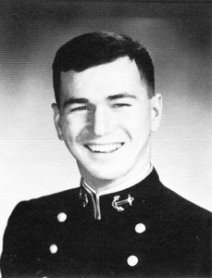
Jerry F. Hogan, LTJG USN
DOD: 1/21/67
Panel 14E, Line 63
Missing in Action 1/21/1967. LTJG Jerry Franks Hogan, USNA Class of 1964, is one of those 1,587 MIAs unaccounted for in Southeast Asia from the Vietnam War.
Jerry was lost when his A-4C Skyhawk, flying from USS Kitty Hawk (CV 63) as a part of Attack Squadron 112 (VA-112), crashed on January 20, 1967 during a nighttime strike in North Vietnam. From Chris Williams at the Defense POW/MIA Agency on April 19, 2018: "He was part of a two ship strike against shipping traffic (barges) on a river south of Thanh Hoa; he and his strike leader dropped flares in order to prosecute their targets, and he dove his aircraft at the targets. The flight leader then saw another explosion near the river in a marshy area, and soon realized that was Hogan's plane when he no longer responded to radio calls."

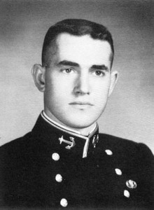
Robin B. Cassell, LTJG USN
DOD: 2/15/67
Panel 23E. Line 7
Missing in Action 7/16/1967 LTJG Robin Bern Cassell, USNA Class of 1964, is one of those 1,587 MIAs unaccounted for in Southeast Asia from the Vietnam War. He is one of 3 graduates from his U.S. Naval Academy at Annapolis class who is still MIA.

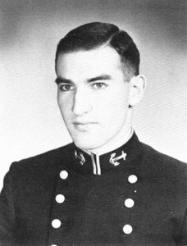
Barry W. Hooper, LTJG USN
DOD: 3/5/68
Panel 43E, Line 7
On March 5, 1968, a River Division 55 convoy composed of five amphibious transport LCUs and three LCM-8 logistical craft, two LCM-6 minesweepers, two-armed patrol craft, and two U.S. Marine Corps armed helicopters, departed Cua Viet bound for Dong Ha to deliver vital cargo to beleaguered allied forces as part of Task Force Clearwater. The convoy commander was LT Barry W. Hooper, USN. As the convoy approached the mouth of the Hien Giang River, it was ambushed by Viet Cong and North Vietnamese forces who were entrenched in heavily fortified bunkers along both banks of the river. The enemy rained a deadly hail of crossfire from heavy automatic weapons, small arms, and recoilless rifles on the convoy. LT Hooper reacted to the ambush in a swift, bold, and decisive manner as he climbed to the conning area of the YFU-64, on which he was embarked, and from an exposed position, he effectively directed the convoy units in evading the enemy fire and returning accurate suppressive fire at the enemy positions. For 30 minutes the battle raged, and as the last unit had cleared the ambush zone, YFU-64 received a direct hit in the conning area that mortally wounded LT Hooper. As a result of his superb leadership, the convoy fought its way through to its destination with the vital supplies it carried.

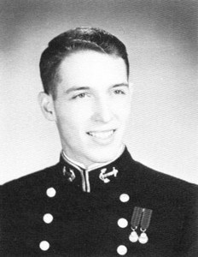
Geoffrey R. Shumway, LCDR USN
DOD: 6/25/72
Panel 1W, Line 49
Lt. Commander Geoffrey Raymond Shumway was awarded the Distinguished Flying Cross for his heroism and extraordinary achievement while participating in aerial flight. He served as a Pilot and was assigned to VA-22, CVW-15, USS CORAL SEA, TF 77, 7TH FLEET. On June 25, 1972, an A-7E Corsair (Bureau Number 157437, side number NL 311) of the VA-22 Fighting Redcocks was shot down by anti-aircraft fire over North Vietnam. The pilot, LT Geoffrey R. Shumway, was never heard from again and declared Missing in Action. The crash site was later located at Xom Bau in the Nghe An Province. LT Shumway’s remains were returned on August 3, 1993 and positively identified on June 12, 2002. He was buried in Arlington National Cemetery. [Taken from a4skyhawk.org]

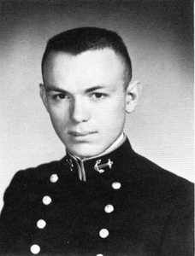
William A. Griffis III, CAPT USMC
DOD: 1/24/70
Panel 14W Line 62
On January 24, 1970, a U.S. Army helicopter UH-1H (tail number 67-17559) from A Troop, 7th Squadron, 1st Cavalry Regiment, was participating in a reconnaissance in force (RIF) operation in the 7th ARVN Division Area of Operations in Dinh Tuong Province, RVN, ten miles to the north and northwest of Vinh Lo+ng. During the operation, the helicopter was entering a landing zone when a booby-trapped /*-*-/ammunition container exploded. The gunner on the aircraft, SP4 Nathanial Thomas, and a passenger, U.S. Marine advisor CAPT William A. Griffis III, were killed by the blast. Two Republic of Vietnam Marines were also killed, including the executive officer of the 4th Infantry Battalion. Three U.S Army personnel were wounded, and the helicopter was completely destroyed after crashing.

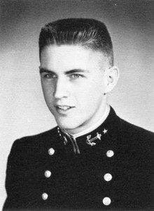
Charles C. Parish, LT USN
DOD: //25/68
Panel 50W Line 8
LT Charles C. Parish USNA Class of 1964, is one of those 1,587 MIAs unaccounted for in Southeast Asia from the Vietnam War. He was one of 3 graduates from his U.S. Naval Academy at Annapolis class (1964) who were MIA at one point.

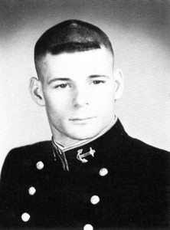
Michel R. Collins, LT USN
DOD: 3/4/71
Panel 4W Line 21
The President of the United States of America takes pride in presenting the Silver Star (Posthumously) to Lieutenant Michael Raymond Collins, United States Navy, for conspicuous gallantry and intrepidity in action during operations against enemy forces in the Republic of Vietnam on 30 January 1971. As leader of a fifteen-man SEAL patrol assigned the mission of capturing the leaders of the Saigon-Cholon foreign proselyting section, Lieutenant Collins successfully led two of his three elements through a heavily booby-trapped enemy area before encountering heavy automatic weapons fire from a large enemy force. Remaining calm, he strategically deployed his force to counter the enemy fire, and then ordered his radioman to scramble air support to aid in suppressing the fire of the well-dug-in enemy force. Simultaneously, he called for helicopters to evacuate his casualties. Lieutenant Collins moved about the area to survey the situation and discovered that one of his men had been fatally wounded and two were critically wounded by the initial volley of enemy fire. When the corpsman arrived at the scene, Lieutenant Collins was administering mouth to mouth resuscitation to one of his stricken teammates, following which he returned to the security element and continued to direct a heavy volume of fire toward the enemy. While members of the patrol were boarding the SEAL Support Craft, the Vietnamese interpreter was wounded by enemy fire. Lieutenant Collins, fully exposing himself to the withering fire, dragged the wounded man to a small ditch and administered first aid. He then carried the man to the boat through a continuous rain of fire from the pursuing enemy and directed the boat to get underway to a secure location where he supervised the evacuation of his stricken comrades. By his calm, cool, and decisive actions in the face of withering enemy fire, Lieutenant Collins prevented almost certain disaster for the entire platoon at the hands of a vastly outnumbering force. His inspiring performance of duty was in keeping with the highest traditions of the United States Naval Service.
See https://valor.militarytimes.com/hero/315397
he Boss on the early morning hours of 3 March 1971 ran an operation into the Than Phu Secret Zone, up a small tributary off the Ham Laiong River near the South China Sea. Insertion was by Medium SEAL Support Craft (MSSC) with the boat carrying all remaining members of X-Ray Platoon. A well laid out enemy ambush had been set. In a small river they let the boat go past the first ambush site up the river about 300 to 400 more yards a second ambush site had been posted. Once the firefight started the boat had to turn around and make its way thru the initial site and down river into another ambush site, which had the enemy covering both sides of the river.
In the initial firefight a rifle launched grenade exploded directly above Mike's head and he suffered massive head wounds. Medivac's were called in but refused to come in close due to massive enemy gunfire that was still going on. A black warrant officer (that has just died within the last few years) took control. After numerous requests for the helo's to come in and get Mike (they refused) he told them if they flew their helo’s anywhere near our boat that he would blow them out of the air himself.
Thirty to forty-five minutes later they were able to get Mike on board and headed for the Third Surgical Hospital at Binh Thuy. Mike died shortly prior to the helo landing at the hospital. But I can honestly say I believe it was for the best due to the nature and extent of the wounds. Stateside shut X-Ray Platoon down on the 4th of March and retired the Platoon's name.

